**SAP BW/BO Exercise**

**Exercise: Data Visualization Using**

**SAP Lumira Server**

**Student Name: Nupur Ray Student Id: nxr163130**

**Date: 06/11/2016**

**Note: You must use the following conventions to name objects/systems created in this exercise.**

**Replace SM with A - for Fall semester**

**B - for Spring semester**

**C - for Summer semester**

**Replace YY with the last 2 digits of the current year.**

**Replace XXX with your SAP ID.**

**Objective**

Get familiar with the data visualization capabilities of SAP Lumira Server.

After having the Twitter data loaded and prepared for the Sentiment Analysis, production planner wants to present his findings to vice president operations. Production Planner knows that “a picture is worth a thousand words”, i.e. the best way to explain the findings is to present them graphically. Always striving for the best performance and newest technologies, he decides to use SAP Lumira Server for the visualization of the acquired data. As it provides multifarious possibilities to analyze and represent the data in an easy way.

**1) Create an Analytic View**

As the creation of Analytic Views is not yet implemented within the SAP HANA WebIDE, we will use the SAP HANA Studio to create an Analytic View.

Open your SAP HANA Studio and logon to your SAP HANA system. Go to

Content ► gbi-student-###

Right click on the package “TwitterLoad” and choose:

New ► Analytic View…

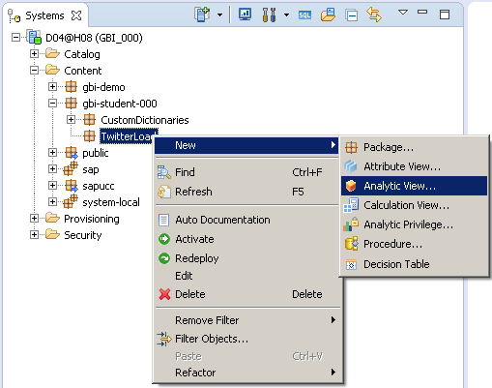

Enter “AV_IPAD_PRO_###” into the field “Name”. Enter “Analytic view for $TA_iPadPro_Sentiment_000” into the field “Label”. Then click on **Finish**.

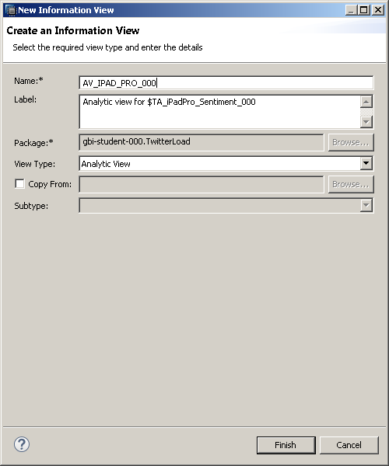

The editor for analytic views opens. Click on the green plus next to the field Data Foundation on the right of the screen.

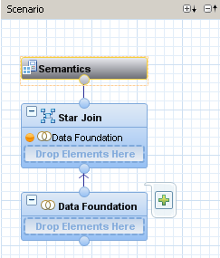

Search for the term “iPad” and choose the table “$TA_iPadPro_Sentiment_### (GBI_###)”. Then click on **OK** to add the table to the analytic view.

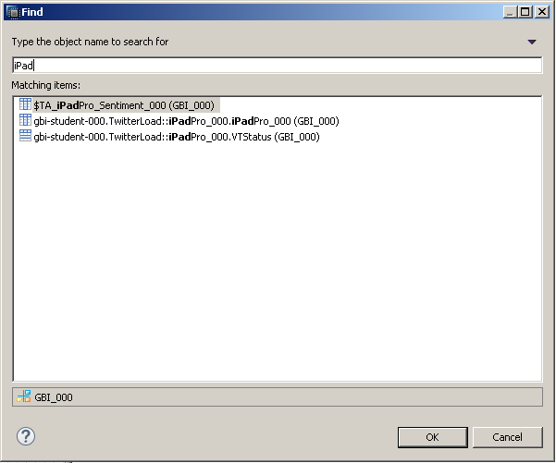

Add the following columns to the output:

* Id
* TA_TOKEN
* TA_LANGUAGE
* TA_TYPE

You can do this either by right clicking the columns and choosing **Add To Output** or you can click on the grey bubble in front of the column name.

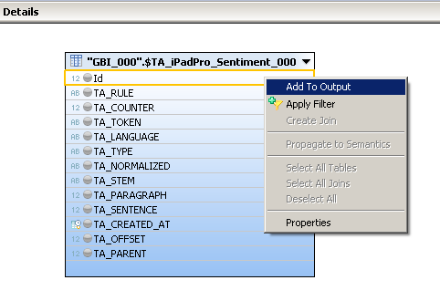

The result should look as shown in the screenshot below:

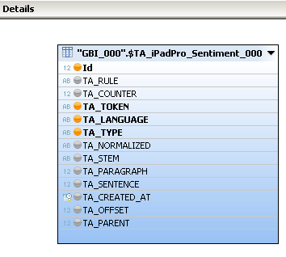

**Paste your screenshot here.**

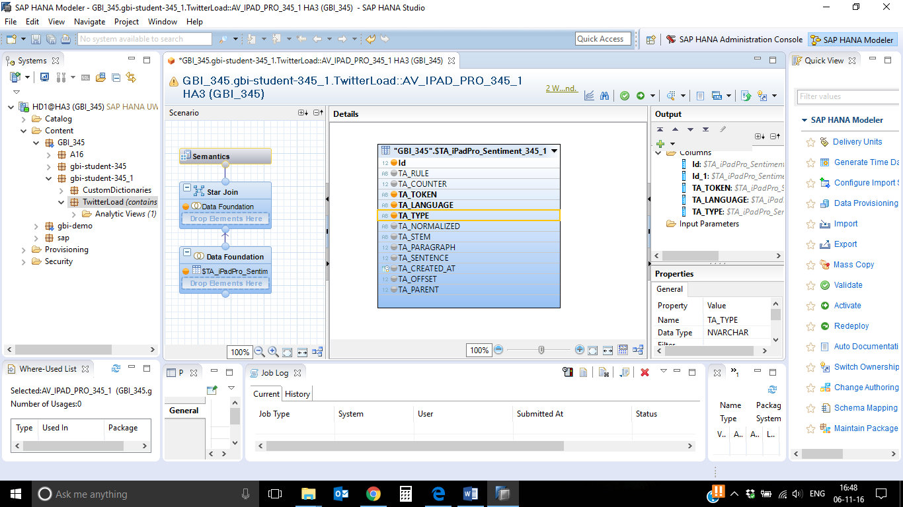

Surface Pro 4-

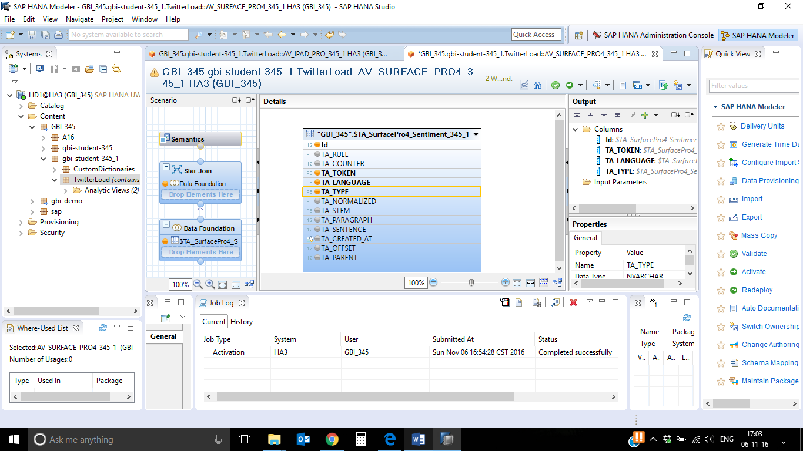

Now we want to filter the column “TA_TYPE” for sentiments because we only need rows with the type “Sentiment” for the visualization. Right click on the column “TA_TYPE” and choose **Apply Filter.**

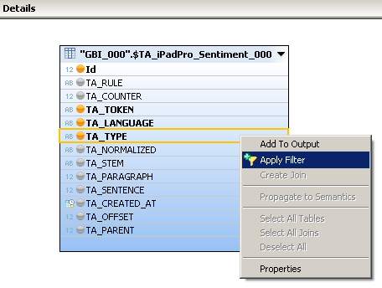

Choose “List of values” in the dropdown field “Operator”. Enter “MajorProblem, MinorProblem, NeutralEmoticon, NeutralSentiment, StrongNegativeEmoticon, StrongNegativeSentiment, StrongPositiveEmoticon, StrongPositiveSentiment, WeakNegativeEmoticon, WeakNegativeSentiment, WeakPositiveEmoticon, WeakPositiveSentiment” into the field value. Click on **OK** to add the filter.

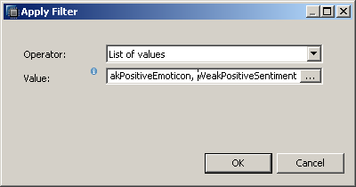

Click on “Semantics” on the left of the screen. Change the type of the columns to the following values:

|  |  |
| --- | --- |
| **Column** | **Type** |
| Id | Measure |
| TA_TOKEN | Attribute |
| TA_LANGUAGE | Attribute |
| TA_TYPE | Attribute |

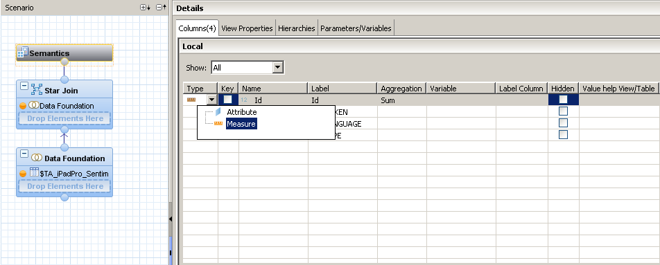

Change the Aggregation for the column “Id” to “Count” (see screenshot below).

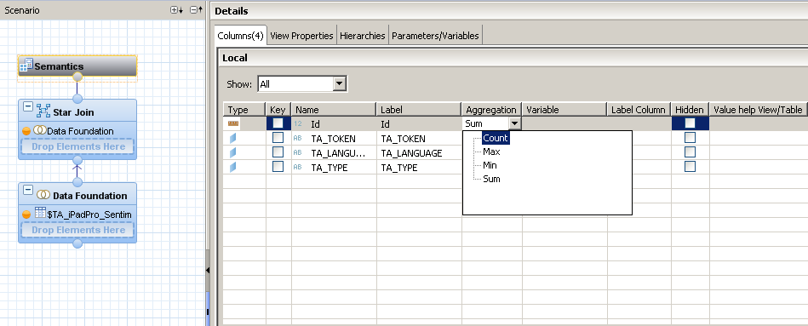

Click on the button  **Save and Activate** in the upper right corner. You can check whether your analytic view was activated successfully in the Job Log on the bottom of the screen

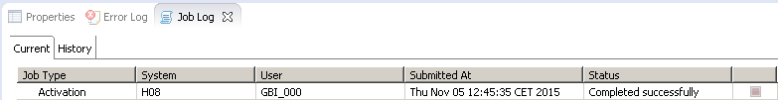

**Paste a screenshot of Job Log.**

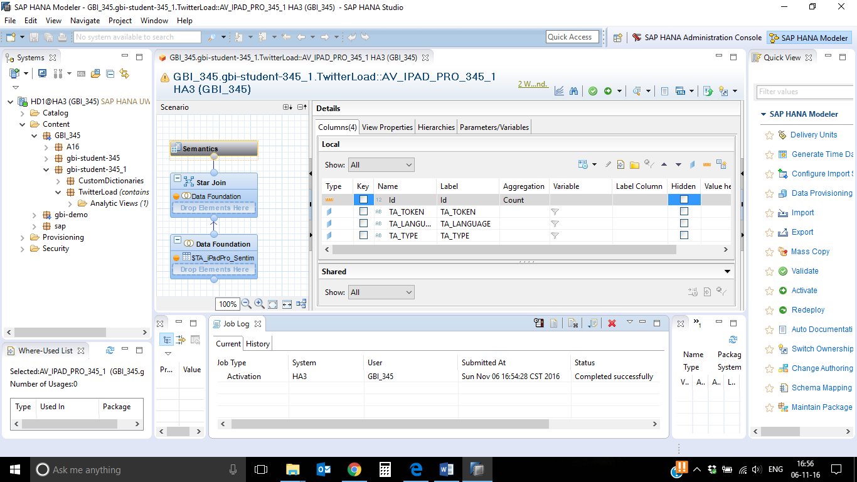

Repeat the steps from this scenario for the table “$TA_SurfacePro4_Sentiment_###”. Name the analytic view ”AV_SURFACE_PRO4_###”.

**Paste a screenshot of your Job Log.**

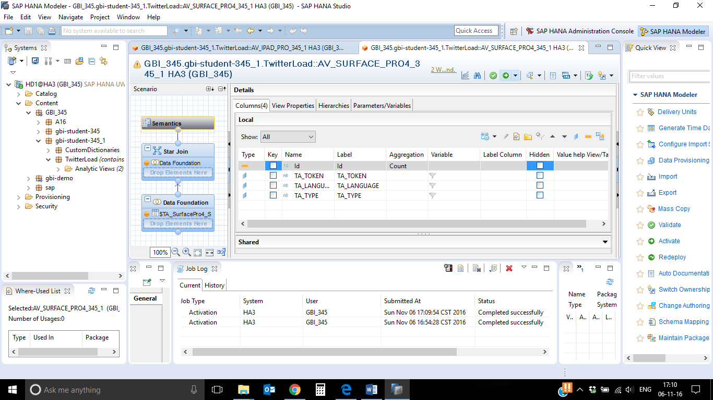

**2) Create a Tag Cloud with SAP Lumira Server**

**A tag cloud is a nice tool to find out which terms are used very frequently in a given data set. Jun Lee wants to get an overview about the sentiments. He thinks it is a good starting point to use a tag cloud for visualization.**

Open the SAP Lumira Server of your SAP HANA system in the browser:

<http://hd1.hana.ucc.uwm.edu:8003/sap/bi/launchpad/>

You will find your analytic views in the list (see screenshot below).

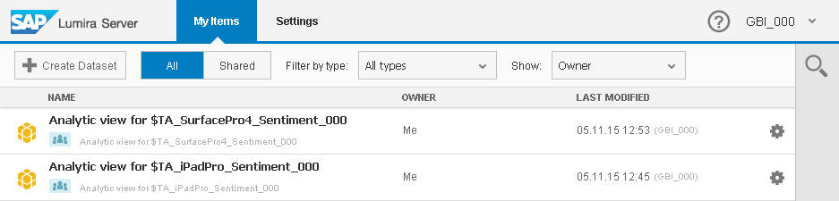

Click on the view for the table “$TA_SurfacePro4_Sentiment_###”. The Visualize perspective opens. Drag and drop the measure “Id” to the field “X Axis” under “MEASURES” on the right of the screen. Then drag and drop the dimension “TA_TOKEN” to the field “Y Axis” under “DIMENSIONS” on the right of the screen. The data will be shown as a bar diagram.

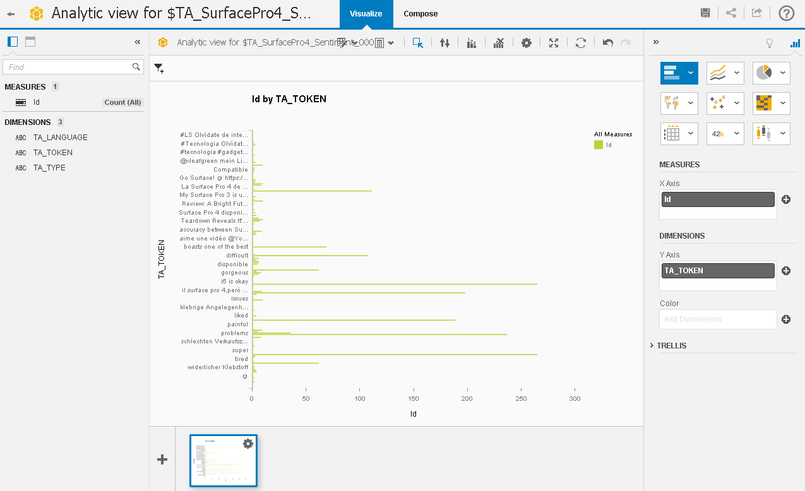

Change the type of the visualization to tag cloud. You can do this by clicking on the icon for others charts . Then, choose Tag Cloud (see screenshot below).

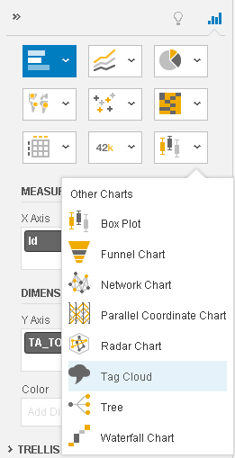

The tag cloud visualizes all sentiments that are stored in the database table. Terms that have been used more frequently are displayed in a larger font size than the others.

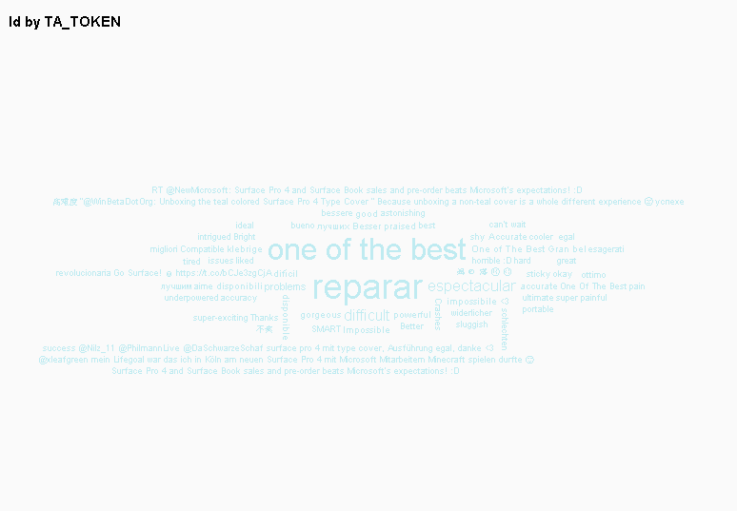

Attention: Please note that the screenshots can look different depending on your data!

**Paste your screenshot here.**

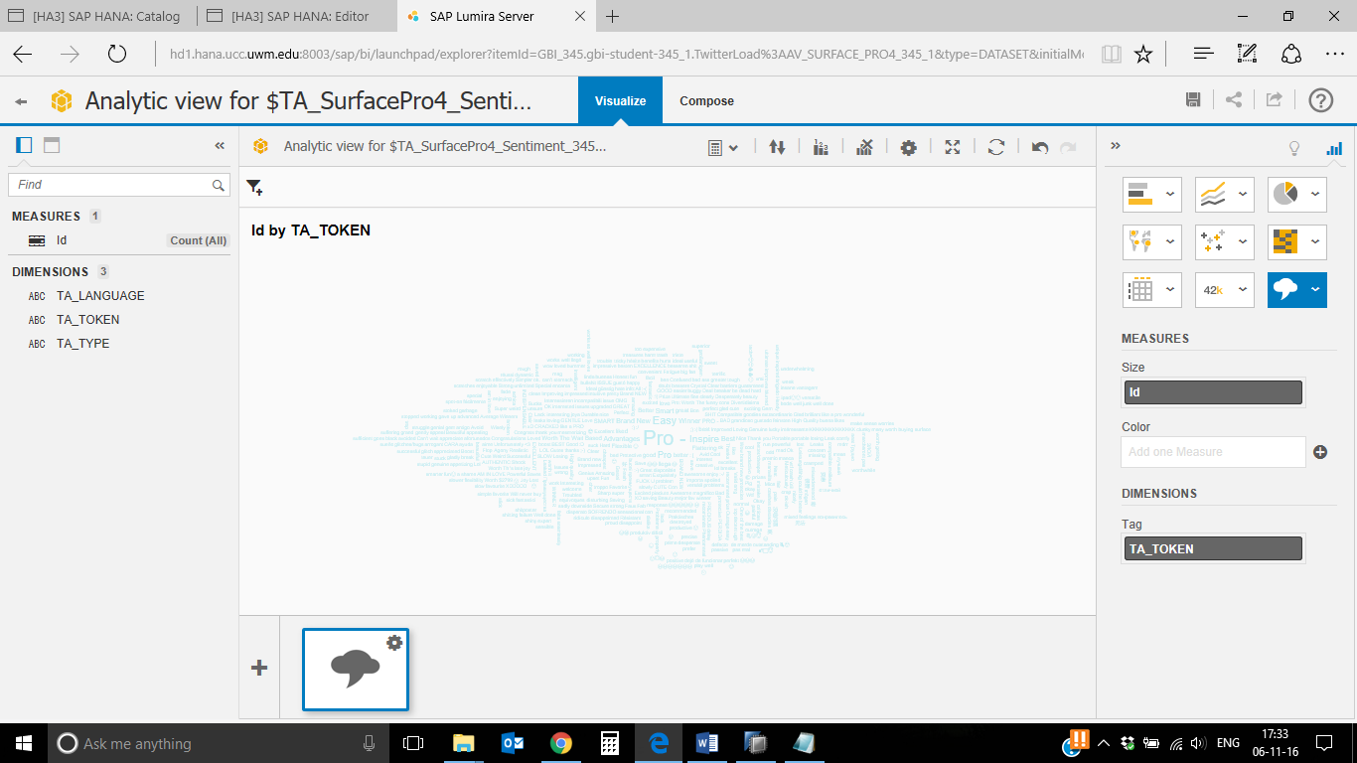

**Ipad pro-**

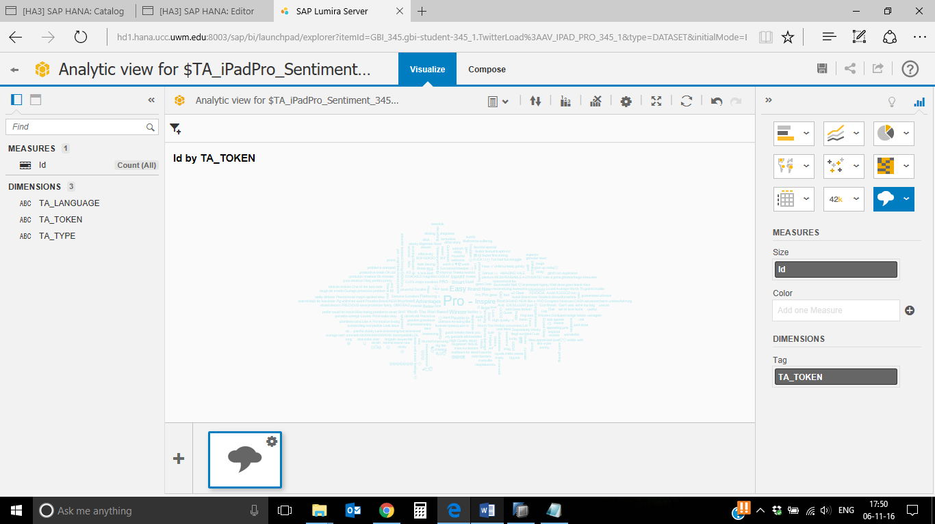

If you want, you can also drag and drop the measure “Id” to the field “Color” under “MEASURE” on the right of the screen. Terms that have been used very often will be displayed in a darker color. On the right of the tag cloud legends with the values will be shown.

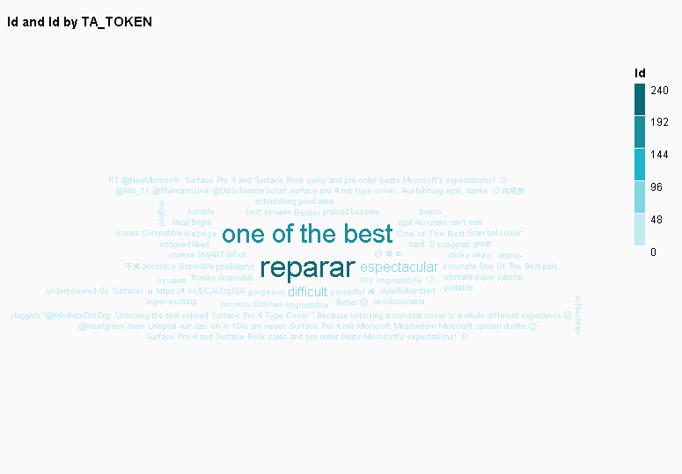

The tag cloud is still not really readable because there are so many terms in it. To solve this issue, you can add a ranking for the column “Id”. Therefore, click on the ranking symbol  at the top of the tag cloud. Enter 20 into the field with the number to show the top 20 sentiments.

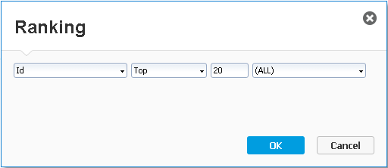

The result is shown in the screenshot on the next page:

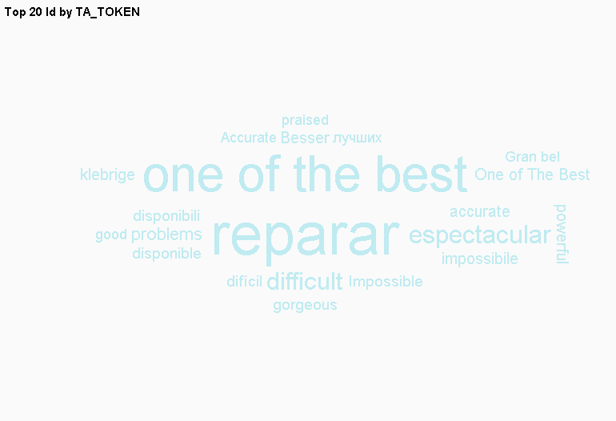

You can see that people say, it is “one of the best” tablets, but they also say there are problems and they had to repair it (reparar).

**Paste your screenshot here.**

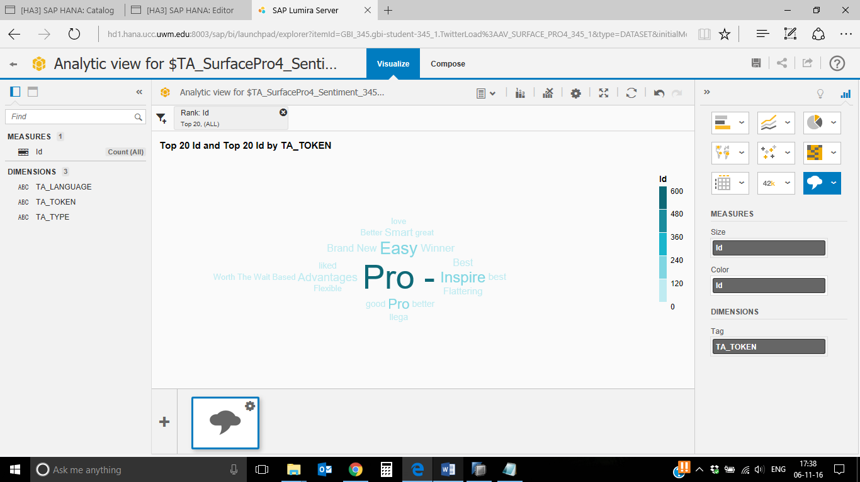

**Ipad pro-**

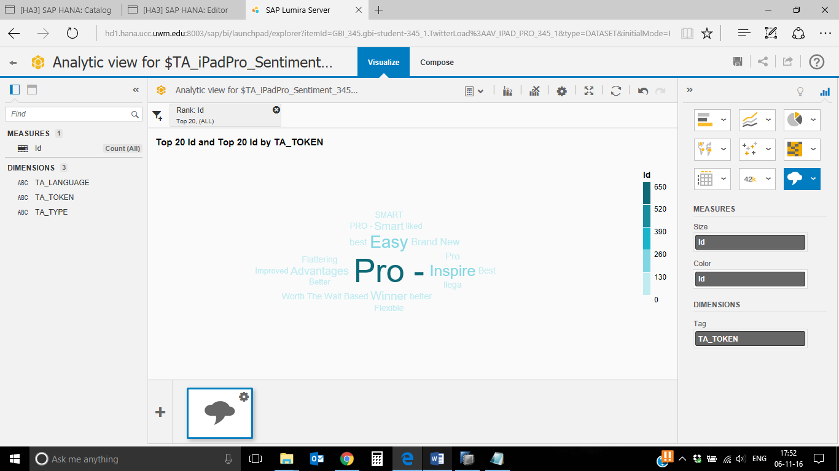

If you want, you can also add a filter for one language. Therefore, click on the filter symbol  on the top of the table. Choose the dimension “TA_LANGUAGE”.

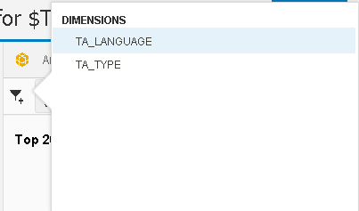

Choose one of the languages from the value list (e.g. “es” for Spanish) and click on **Apply**. You can also add multiple languages to the list.

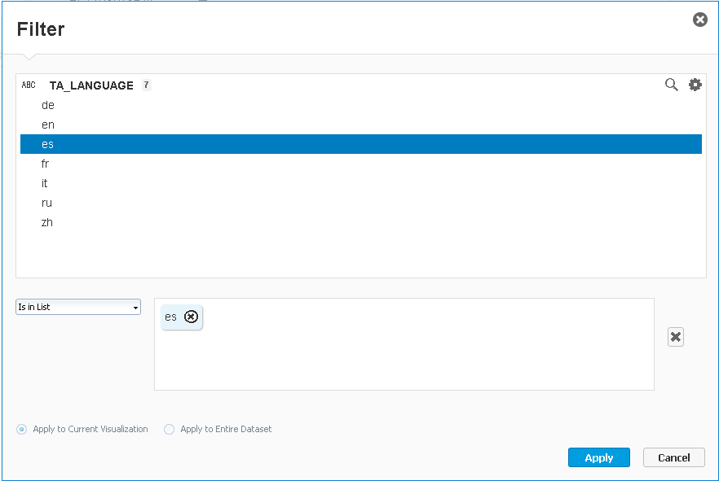

Now your tag cloud changes again and only show terms that were written in Spanish.

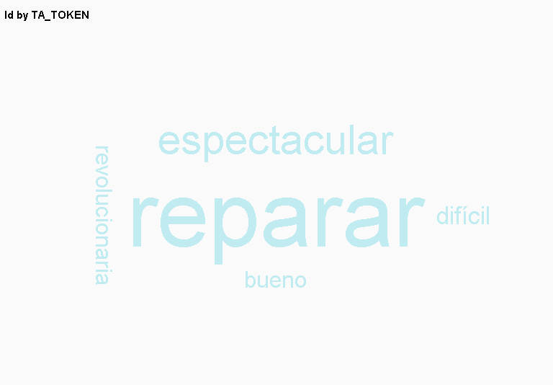

Adjust the diagram for your manager. Then click on **Save** on the upper right corner. Enter SurfacePro4_### into the field "Name" and click on **OK**.

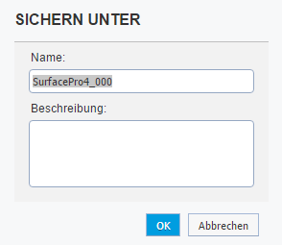

Now you can repeat the steps for the table with the iPad Pro analysis results. In our case, the result for the tag cloud without any additional configurations or filters looks like shown in the screenshot below.

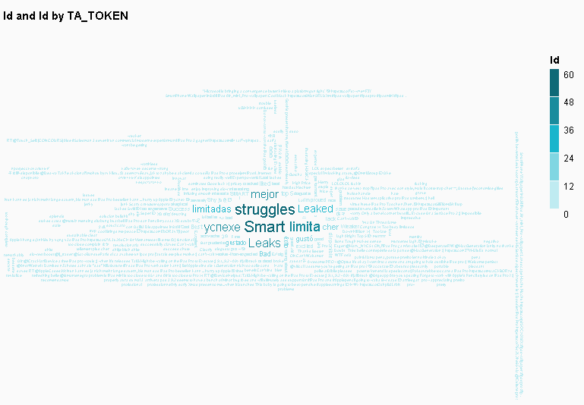

**Paste your screenshot here.**

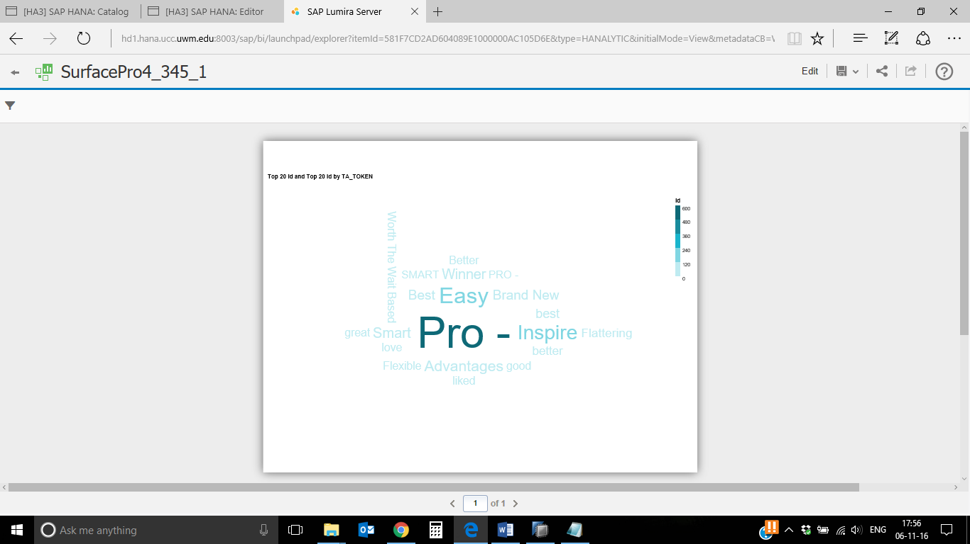

If we filter the analytic view for language “German”, we receive the following result for the iPad Pro.

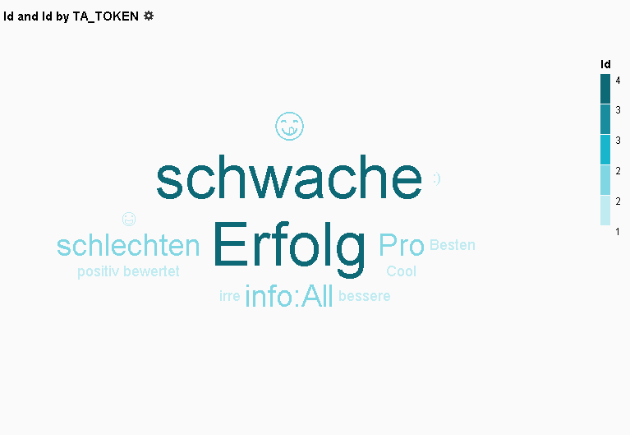

It says that the iPad Pro is a success (“Erfolg”) but there are also people who think that it is weak (“schwache”). In the screenshot you can also see, that emoticons are also recognized as sentiments and can be analyzed by the SAP HANA system.

**Paste your screenshot here.**

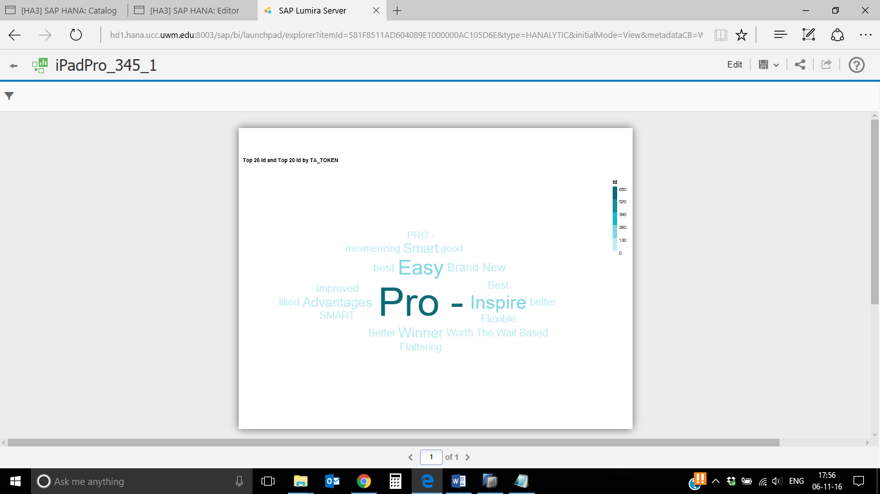

**What sentiments are displayed after filtering the records by language and sorting it by rank.**

1. For Surface Pro 4-

Weak Positive Sentiment like “Pro –“, Strong Positive Sentiment, Neutral Sentiment, Major Problem, Weak Negative Sentiment, Minor Problem and Strong Negative Sentiment.

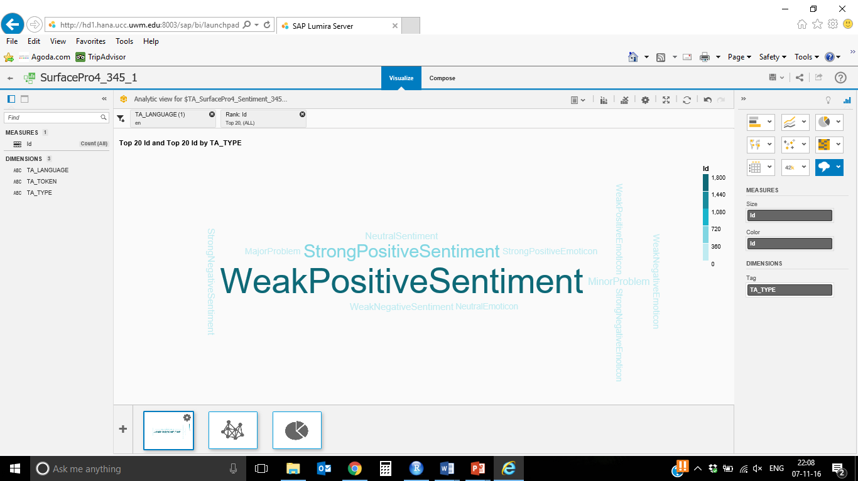

1. iPadPro-

Weak Positive Sentiment, Strong Positive Sentiment, Neutral Sentiment, Major Problem, Minor Problem, Weak Negative Sentiment and Strong Negative Sentiment.

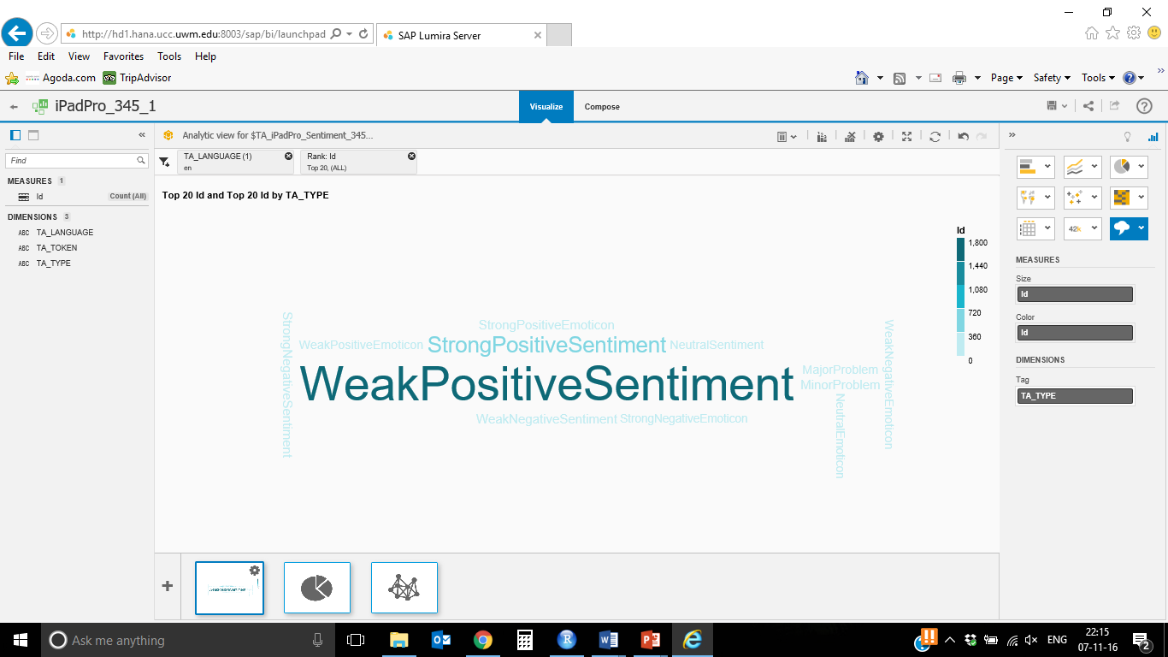

Save the configuration under the name "iPadPro_###".

**3) Create a Network Chart with SAP Lumira Server**

After creating the tag cloud production planner notices that it doesn’t provide any information about the type of the sentiments. He wants to know if there are more positive or negative sentiments. To analyze the data, he creates a Network Chart.

Open the SAP Lumira Server of your SAP HANA system in the browser:

<http://hd3.hana.ucc.uwm.edu:8003/sap/bi/launchpad/>

Click on iPadPro_### in the table.

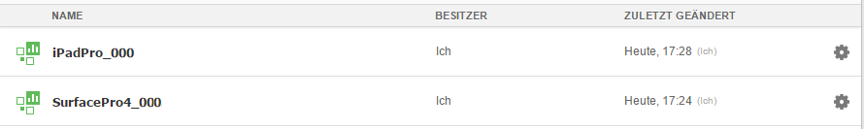

The “Visualize” perspective opens and shows your tag cloud. If the view isn't switched automatically to the edit mode, click on **Edit** in the upper right corner. We want to create an additional chart. Click on the plus symbol on the bottom of the chart.

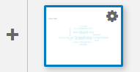

An empty chart will open.

Change the visualization type to “Network Chart”. Therefore, click on the icon for others charts  and choose “Network Chart”.

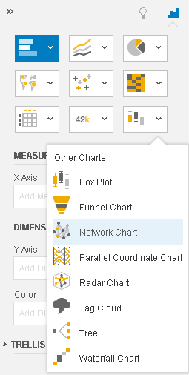

Network charts use dimensions only. Drag and drop the dimension “TA_TOKEN” to the field under “DIMENSIONS” on the right of the screen. Note that the chart in the middle of the screen asks you to add more dimensions to visualize the data.

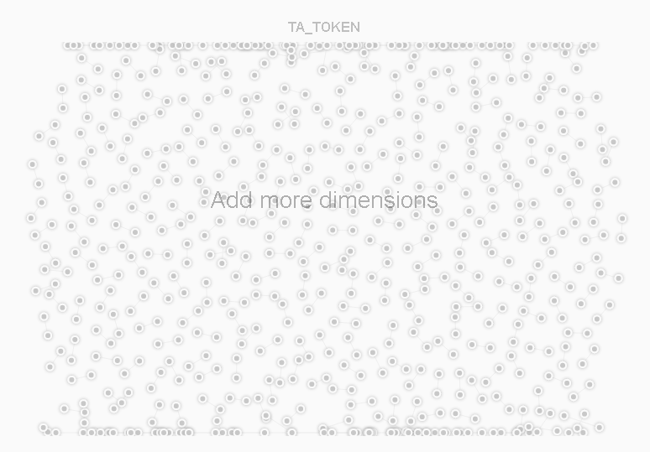

That means that we have to add a second dimension. Drag and drop the dimension “TA_TYPE” to the field under “DIMENSIONS” on the right of the screen.

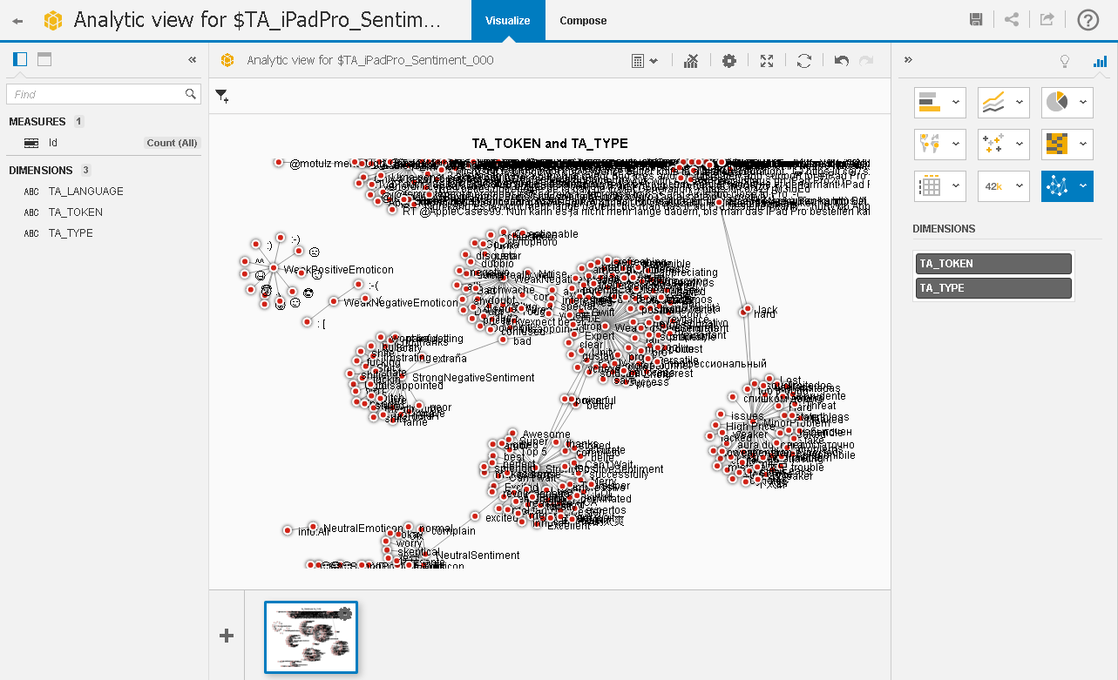

**Paste your screenshot here.**

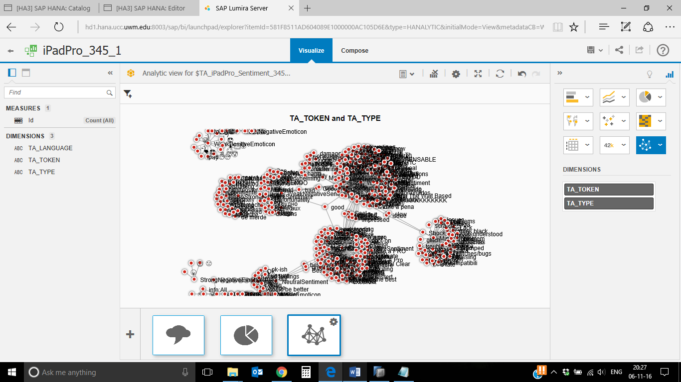

The network chart doesn’t look really readable yet. We need to configure the charts first. Click on the filter  symbol at the top of the chart and choose the dimension “TA_LANGUAGE”. Add one language to the list, e.g. “en” for English.

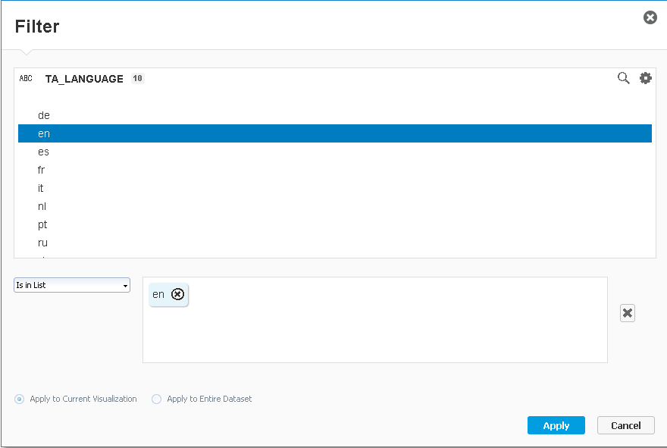

If you click on one spot in the middle of one network segment, you can drag and drop it to another place in the chart. The other network segments will organize their selves. Organize the segments that the positive sentiments are on the right side and the negative sentiments are on the left one.

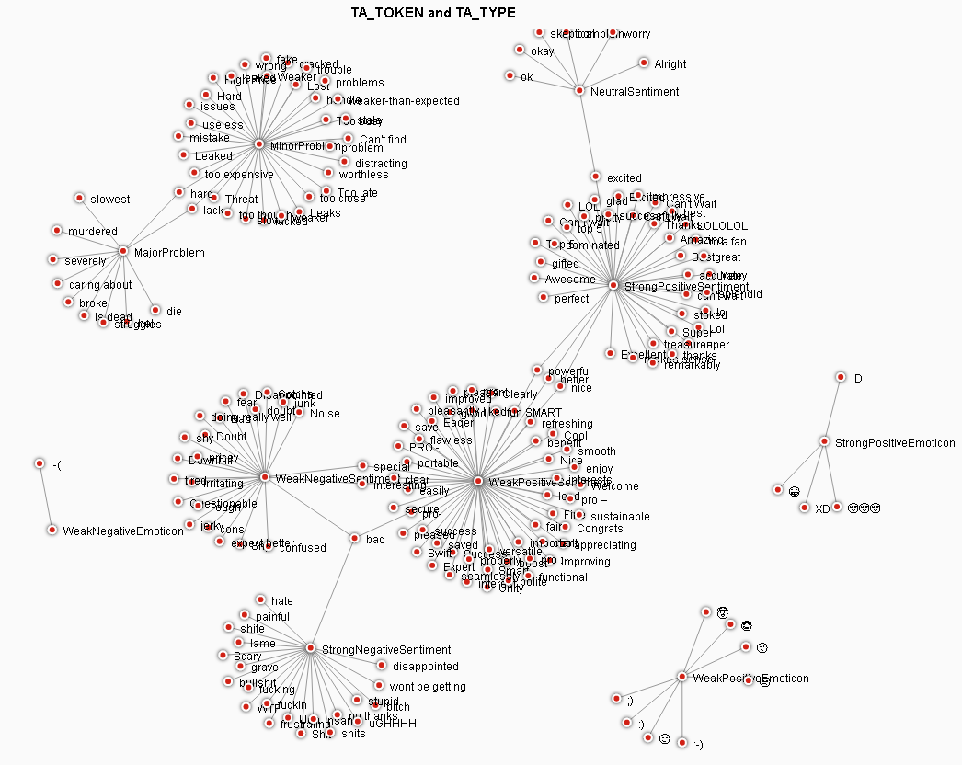

**Strong and Weak Positive Sentiments**

**Negative Emoticons**

**Positive   
 Emoti-  
 cons Weak Positive Sentiments**

**Neutral Sentiments**

In the screenshot above you can see that there are lots of minor problems but just a few major problems. You can also see that there are lots of positive statements about the iPad Pro and some positive emoticons.

**Paste your screenshot here.**

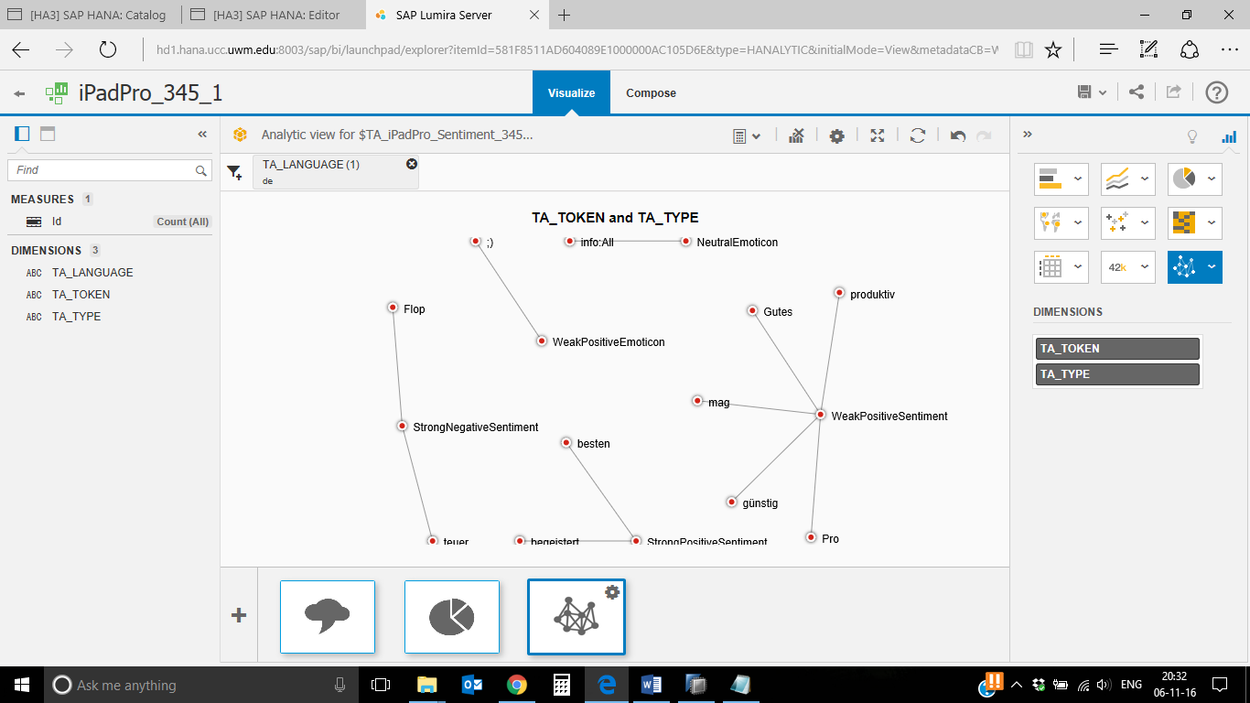

**Which sentiment has the maximum nodes?**

**Weak Positive Sentiment has maximum nodes.**

Click on the **save** button in the upper right corner to save the configuration. You can repeat the steps for the view with the data of the Surface Pro 4. In our case the result looks like shown in the screenshot on the next page. The chart wasn’t filtered for a language.

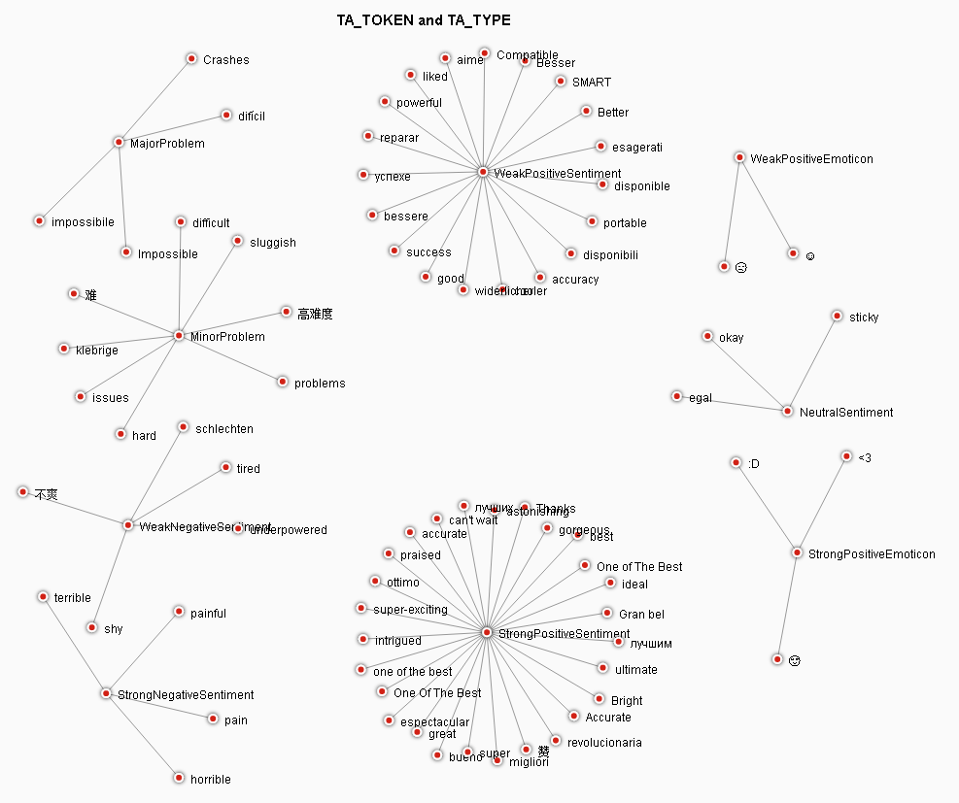

**Strong and Weak Positive Sentiments**

In this case you can see that there are much more positive sentiments than negative sentiments.

**Paste your screenshot here.**

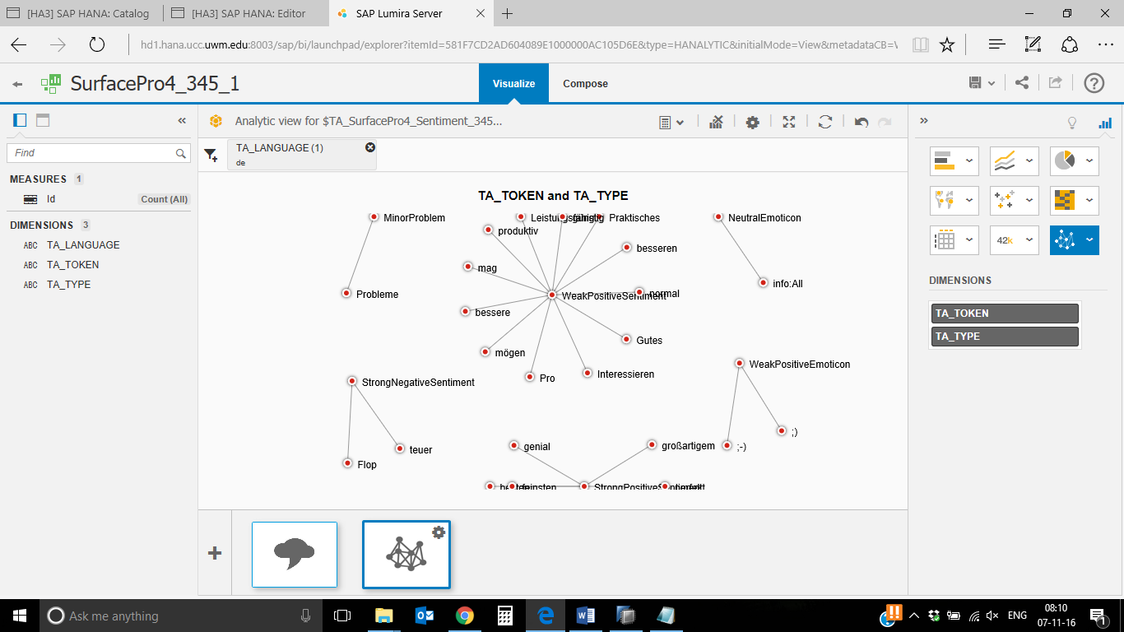

Next, we want to know what that means in numbers.

**4) Create a Pie Chart with SAP Lumira Server**

After creating the network chart production planner needs some real numbers to show to the manager. He creates a Pie Chart to see if there are more positive or negative sentiments. Afterwards he creates the presentation for the manager.

Next we want to extract the real percentages of the sentiments.

Open the SAP Lumira Server of your SAP HANA system in the browser:

<http://hd3.hana.ucc.uwm.edu:8003/sap/bi/launchpad/>

Click on iPadPro_### in the table.



The “Visualize” perspective opens and shows your charts. If the view isn't switched automatically to the edit mode, click on **Edit** in the upper right corner. We want to create an additional chart. Click on the plus symbol on the bottom of the chart.



An empty chart will open. Change the visualization type to “Pie Chart”. Therefore, click on the icon for pie charts  and choose “Pie Chart”.

Drag and drop the dimension “TA_TYPE” to the field “Colors” under “DIMENSIONS” on the right of the screen. Then, drag and drop the measure “Id” to the field “Size” under “MEASURES” on the right of the screen.

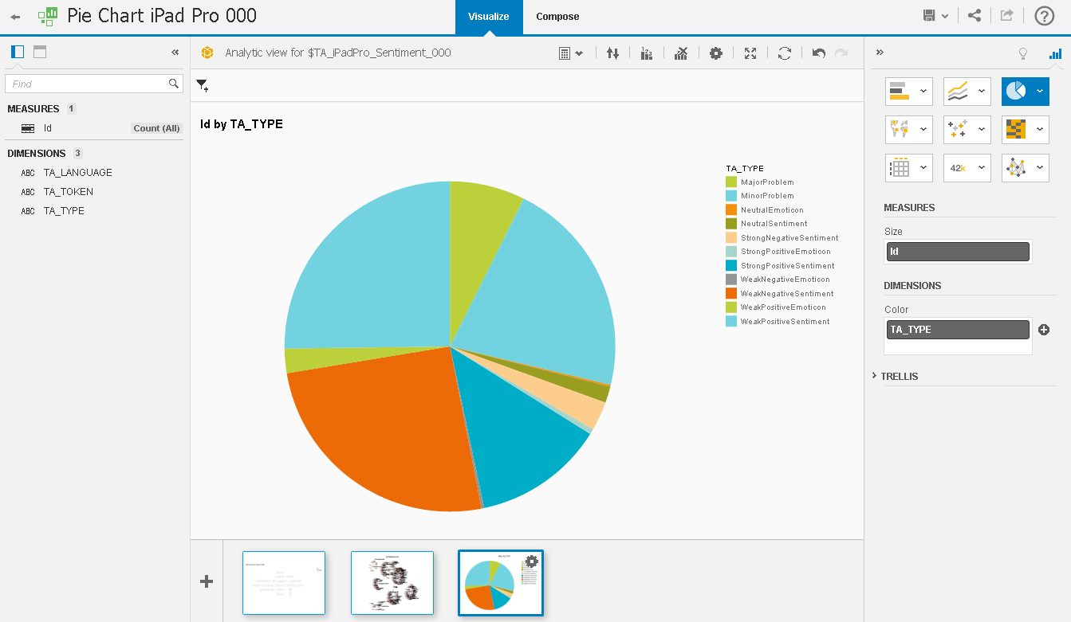

If you want, you can filter out the emoticons, as they don’t influence the overall pie chart that much. Click on the filter symbol at the upper left corner and choose TA_TYPE.

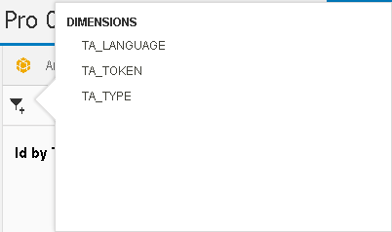

Now choose “Is in List” from the dropdown field and select “Major Problem”, “Minor Problem”, “Neutral Sentiment”, “WeakPositiveSentiment”, “StrongPostitiveSentiment”, “WeakNegativeSentiment” and “StrongNegativeSentiment”. Click on **Apply** to set the filter.

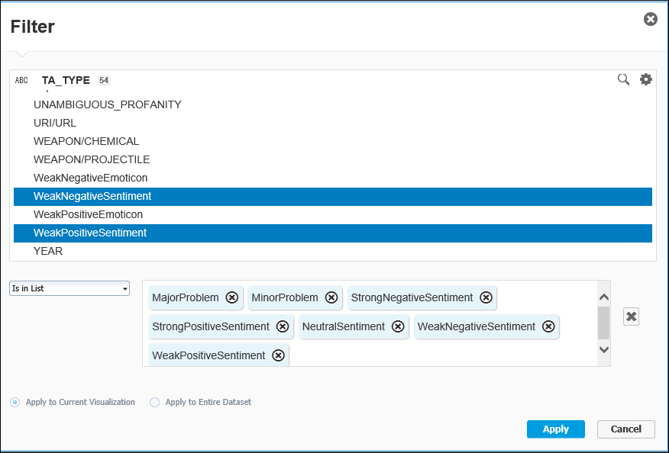

To enable the data labels for the pie chart, right click on the chart and choose **Show Data Labels**.

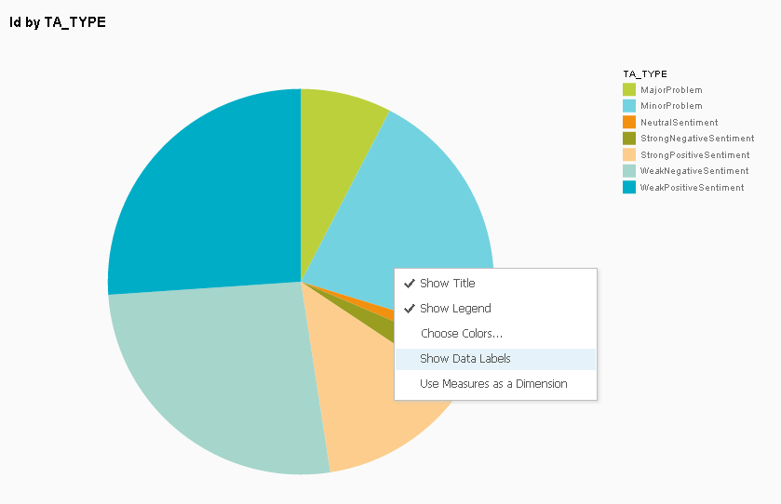

The percentages for all sentiments are shown in the pie chart now.

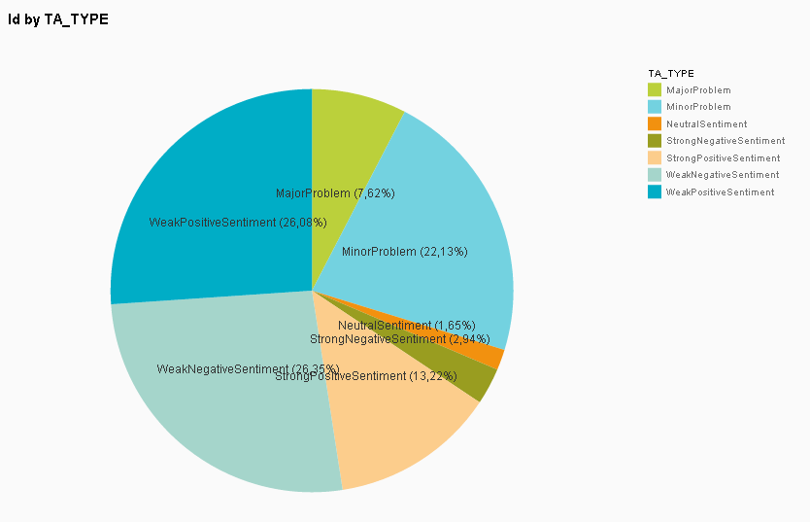

**Paste your screenshot here.**

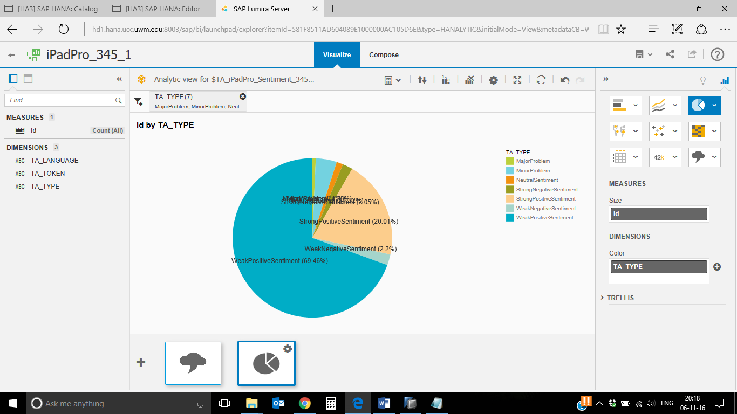

Surface Pro 2-

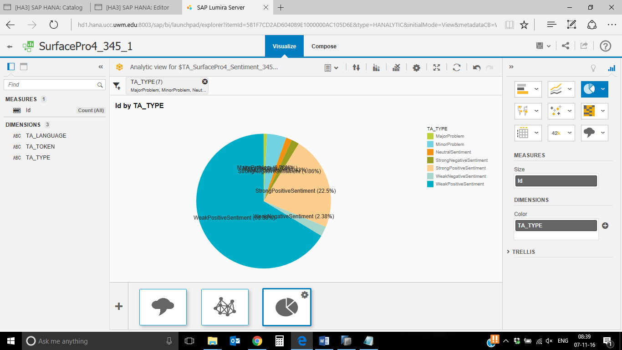

Save your visualization by clicking on the **Save** button on the upper right corner. Next, we want to create a presentation for the meeting with the manager. Therefore, change to the view “Compose” at the top of the screen.

Your charts are shown on the right side of the view. Drag and drop the charts to the white page in the middle of the screen to add them to the presentation. Arrange the charts to present the content vividly. In the next screenshot you can see one example how they can be arranged.

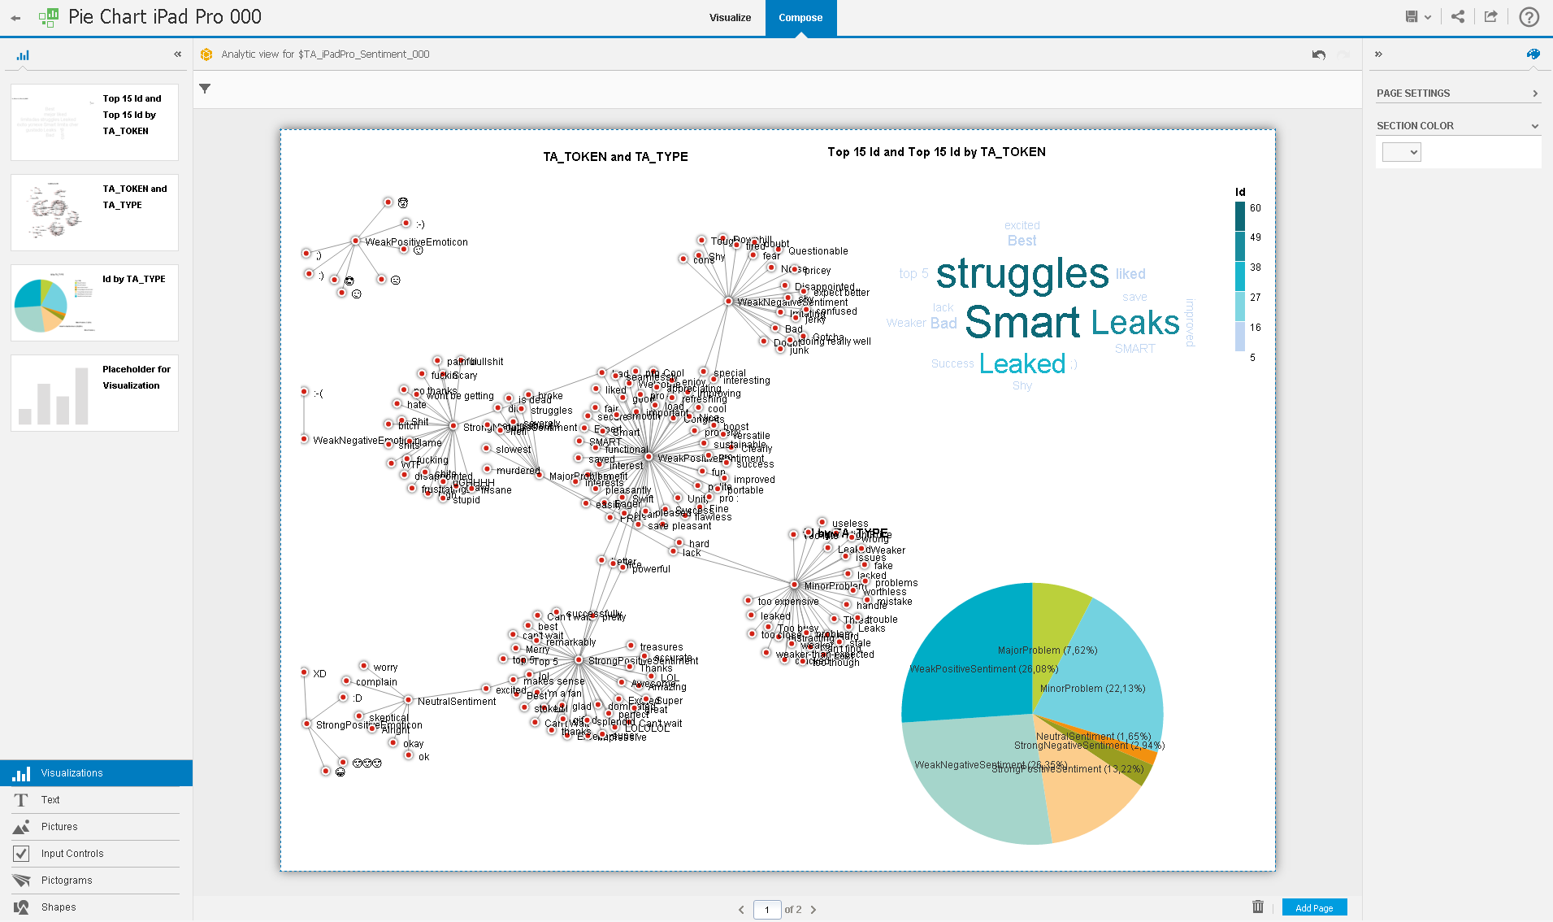

For the presentation we don’t need the titles of the charts. Click on one element, e.g. the network chart. Then, click on the “explore” symbolon the upper right corner of the element. A new screen to explore and change the chart opens. Right click on the element and choose **Show Title**. The missing checkmark tells you that the title was disabled.

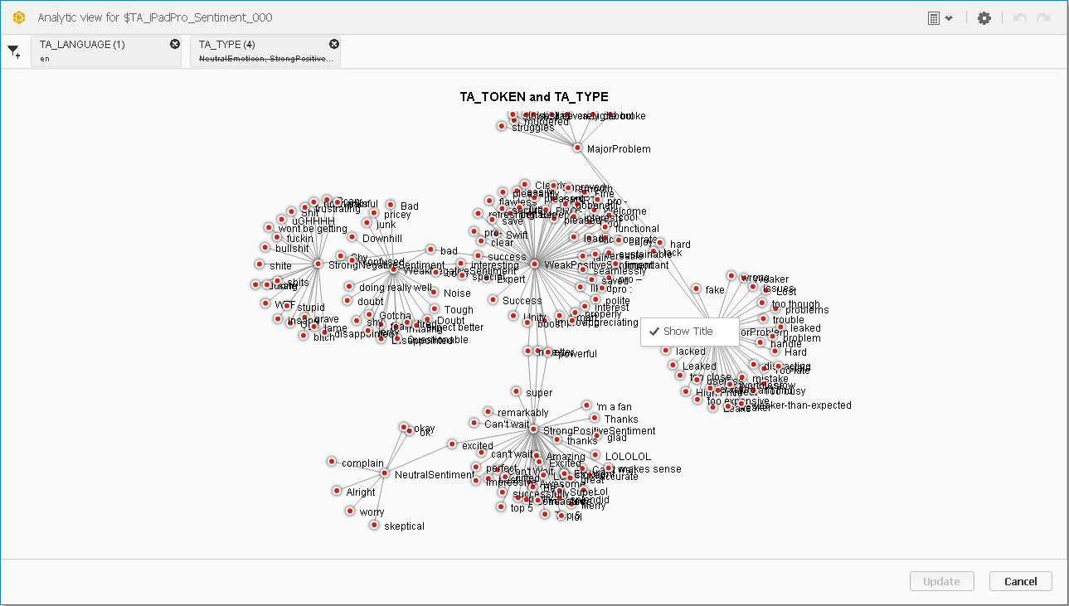

Then click on the button **Update** to save your changes. Do the same for the pie chart and the tag cloud. If you want, you can also disable the legends for the pie chart and the tag cloud. Therefore, go to the explore mode, right click on the element and choose **Show Legend**.

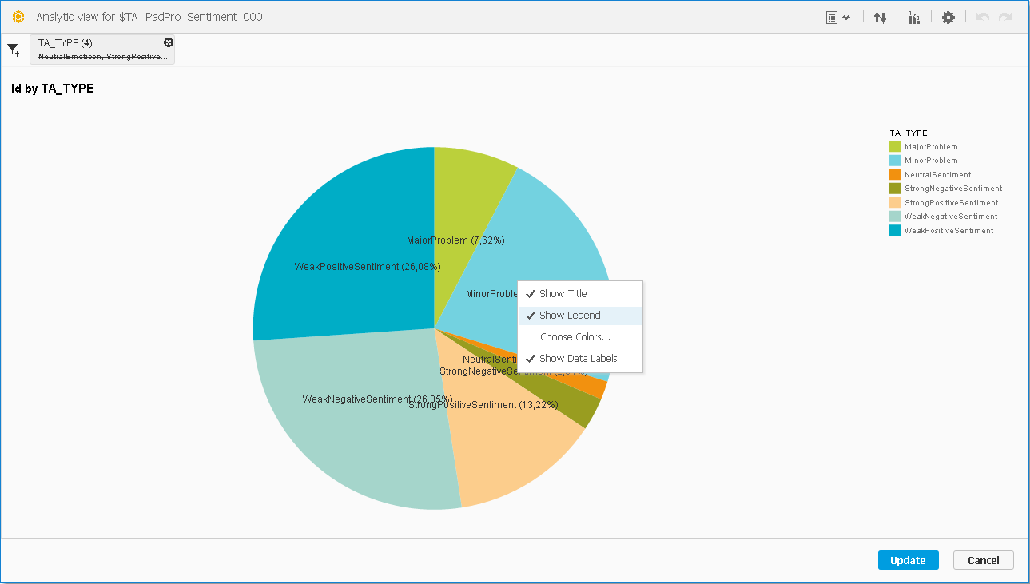

To add a title to the slide, go to “Text” on the lower left corner. Drag and drop the tile “Title” to the slide in the middle of the screen and change the text to “Sentiment Analysis iPad Pro”.

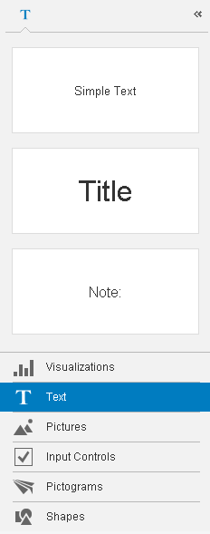

An example slide is shown in the next screenshot.

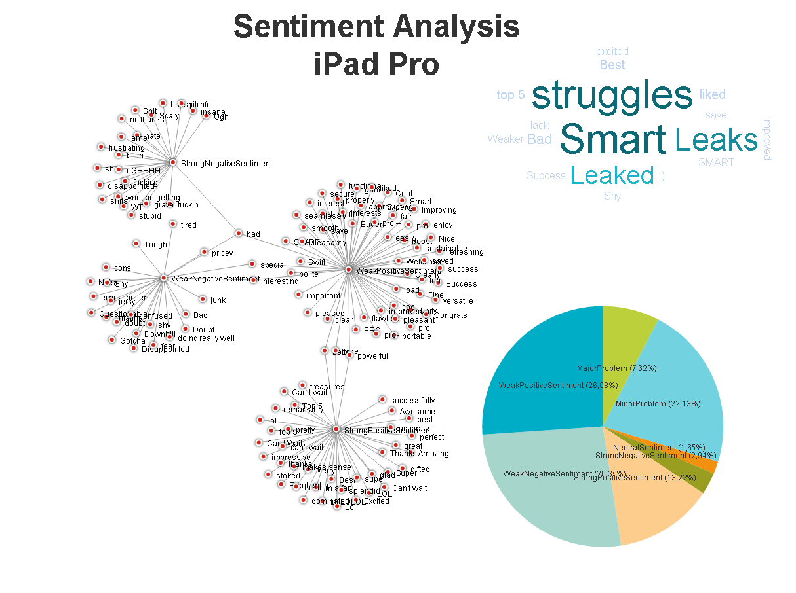

**Paste your screenshot here.**

**Ipadpro-**

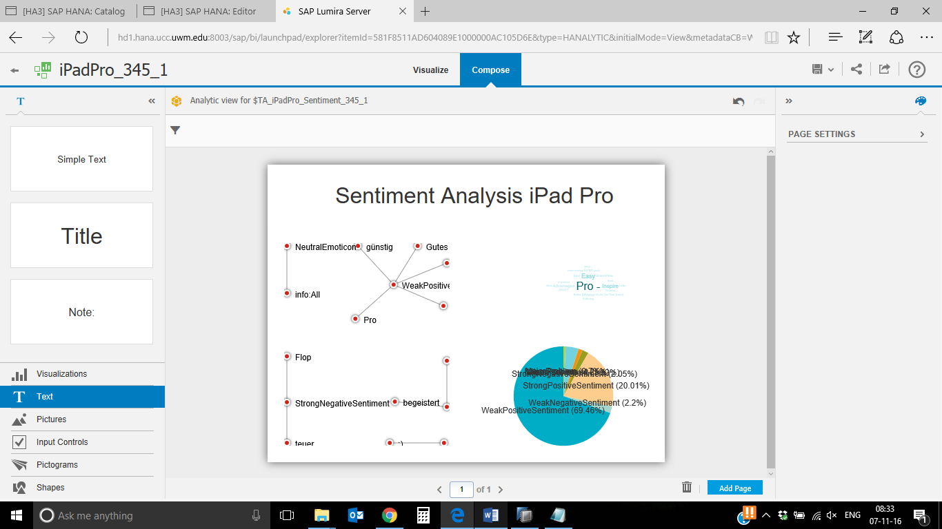

**Surface pro4-**

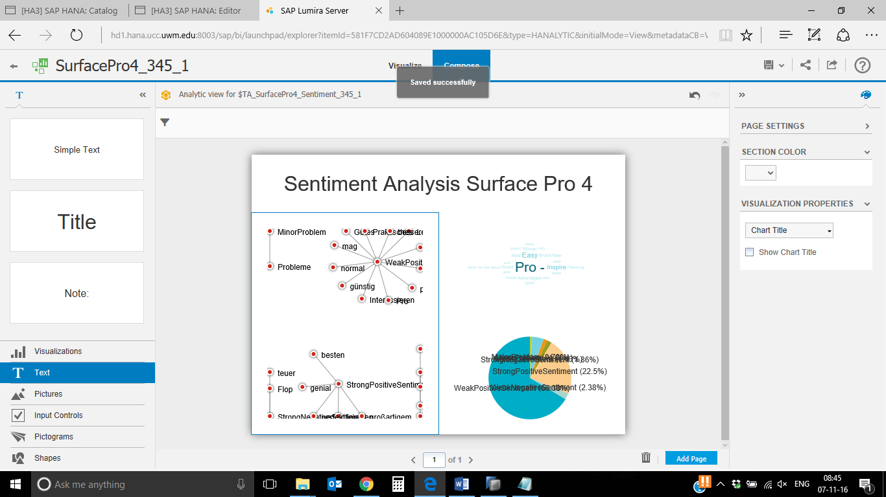

To export your presentation, click on the export symbol  on the upper right corner. A pop-up opens; confirm it by clicking on **Export**.

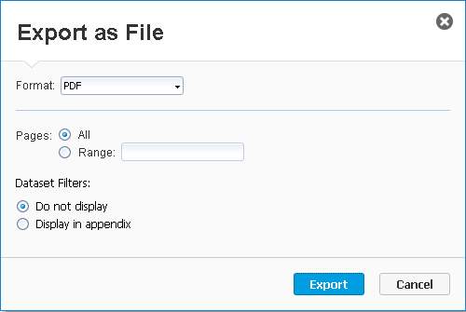

Your slide will be downloaded. Now you can open it to show the presentation to the manager. Repeat the steps from this scenario for the Surface Pro 4 to compare the results.

**Paste a screenshot of your presentation (Surface Pro 4).**

**Surface Pro 4-**

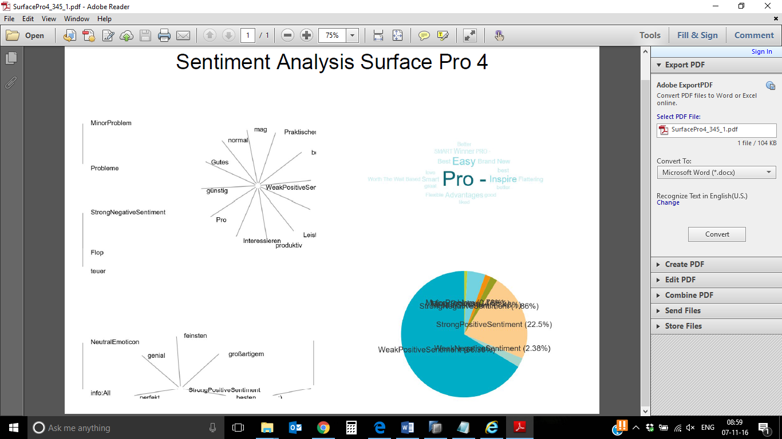

**Ipad pro-**

